

***Better, Safer Retirement Plans***

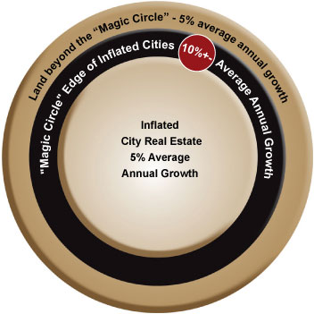

***The Magic Circle***

**We are a family business with 40 years’ experience in developing un-inflated wholesale land investments in the growth areas surrounding major populated cities. We have thousands of clients who have benefited from these seller financed land opportunities.**

**Historically, small affordable land parcels in these areas naturally rise in value at an average of 10% per year, due to the never-ending pressure of the abutting cities. We have nicknamed this area “The Magic Circle”, due the proven superior investment benefits. Long term, Magic Circle land historically experiences a major additional rise in value when the area converts to an inflated city.**

**We are also involved with luxury motorcoach resort and traditional RV resort development, providing individually owned and fully managed cash flow lot ownership.**

**Our Magic Circle land investments are often being purchased by our clients for a Better, Safer Retirement Plan, for short and long term benefits that historically far exceed other investments.**

**Our inventory character varies widely among our vast inventory of land and resort product in various stages of development and acquisition.**

**The unique opportunities and benefits we have created are 1 of a kind and revolutionary in the real estate industry. There are no other companies offering the same opportunities, nor will there ever be.**

**Ask about our $80,000 Research Report that explains why 95% of retirement plans fail, and to learn more about why Magic Circle land is the foundation of a successful retirement plan.**

**One of the best & lowest risk Investments available!**

**Our inventory changes frequently and is subject to change at any time due to frequent sales and increasing demand for our product. All figures are approximate. No guarantees are being made herein.**

**1-877-789-GROW**

**Current Land Inventory ● For Retirement Investment Planning OR Personal Use**

***Special Limited Time Promotions***

**• 10% Money Match made by Hot Spot (on select seller financed purchases),**

**A gift from Hot Spot valued at an average of $38,000.**

**•** **Earn Investment credit in friends and family group rebate credits of $500+ per added group buyer you bring in**

***•* Economy Insurance Protection Plan, see below\***

***Instant savings is being offered***

***for a limited time only, for example:***

**• 1st time seller financed buyers save 5%**

**• Cash buyers & multiple lot buyers save 10%**

**• 2 lot cash buyers save 15%**

***Seller Financing – No Credit Check & No Credit Reporting***

* ***Down Payments from $500+***
* ***Monthly Payments from $199 (starter plan) to $399+***
* ***12 months same as cash or up to 30 year loans***
* ***Average Pricing from $59,755+***

**Economy Insurance Protection Plan**

*In case of a financial hardship our Clients may skip up to 6 consecutive payments or pay a 50% reduced payment for 12 months. Allowable up to 2 times once a reasonable amount of principle has been applied towards the account by the client, at our discretion (we prefer to see at 10%+ principle accrued). Unless otherwise approved this allowance must be at least 5 years apart if utilized 2 times. All amounts deferred (paid later) will be added to the back end of the loan accordingly.

***40 years developing....Thousands of happy clients.....& Counting!***

**TESTIMONIALS • 1-877-789-GROW**

***Value tripled in 5 years…***I have seen the value of my land go from $20,000 to $60,000 in 5 years.

I wish I could buy 100 of these things.*— Robert Hobusch*

***Hot Spot paid me $10,000 in 45 days…***This is the second piece of property I have purchased from this company. I feel it is a great investment, so I have shared this with my Hispanic community, and as a result, many of them have purchased property in Elk Meadows. They feel comfortable with the agent who sold them and I interpret for my friends when it is needed. The group discount rebate totaled $10,000 in 45 days, and counting, as of 11-1-08*. — Jorge Ramirez*

***No credit checks… No credit reporting… flexible during tough time…*** I bought my lot in 2007 and the attractive thing to me that this company offers is the seller financing. I didn’t have to qualify for credit and they don’t report you to the credit bureau if you miss a payment. They work with you when you can’t make a payment, until you get caught up.*— April Rylander*

***Rental Rates nearly tripled in a few years…***Since Hot spot Investments converted Sand Hills Resort to lot ownership, I have seen the rental rates nearly triple in just a few short years, increasing the income for the lot owners. As an owner, and an active POA board member, I have watched the growth and activity in the park from down the street where I live. I have watched the resort for 30 years, and the growth has been the most amazing aspect. Our children grew up riding in the dunes. The dunes are truly spectacular!*— David Crapo*

***Values doubled in 2 years…***I have seen the value of my land double in just 2 years. When my income wouldn’t cover my payments, I was grateful for their leniency towards my payment ability. Because this company stuck with me during tough times, I was able to keep my additional equity I had earned, and continue to earn to this day.*— Ken Browning*

***Water Sale Refunded 100%…***We had purchased water from Red Z Inc and later found it was not transferable to the location where   
we needed it. They honored a 100% money back guarantee and it was handled in the best way it could have been, in the short time we needed, in a kind manner.*— Ann Scottern*

***Balloon Extension Granted…***I received a notice my balloon extension was due and it caught me off guard. I was given two extensions to meet the balloon pay off and I was very appreciative. It came at a great timing with our family’s challenge with

the economy today. *— Herb Basso*

***$1,500 refunded for marriage proposal…***Jaime, I can’t tell you how much the $1,500 helped! I was able to buy a ring the day before we left to Southern California on vacation. I proposed on the Santa Barbara Pier. You didn’t have to refund my money but you did and that tells me a lot about you. Thank you so much and I’ll be in touch. I would love to use that letter of credit with you in the future. Take care bro!

*— Roger Campbell*

***Letter of credit issued…***I had never heard of a company that offered a letter of credit until I did business with Hot Spot Investments. When I had to let my lot go, I knew that I would be back once things picked up with work, and to my surprise, they have a policy to issue a letter of credit for when I come back. Knowing that I hadn’t lost my hard earned equity was worth thousands, literally! Wouldn’t it be nice if all companies worked this way.*— CR Elliot Enterprises*

***Built our cabin pad, installed our septic tank…***When the time came to put our cabin on our Elk Horn lot, these guys removed   
the debris from my lot, constructed a large flat pad with an access road, and best of all, they were there until the job was complete, finishing   
ahead of schedule. — *Fred Hobusch*

***Traded 100% of my equity…***When I decided that I wanted a local recreation property, I was able to trade the equity from my out

of state properties into one of hot spot’s local properties. It worked out great and they did it without any hesitation, within 7 days of the

verbal arrangement.*— Brad Wittisun*

***Created cash flow…***I ended up purchasing 7 properties and was able to resell some of them immediately for a substantial profit above what I paid. The cash flow and down payment income was far above my expectations. Hot Spot even gave me 1 year with no payments on my 2 properties to help boost my portfolio, and worked with me on payments as I sold the properties. I strongly encourage people to take advantage of the opportunity. I still haven’t found anything that compares*. — Hans Jorgensen*

**Development & Information Index:**

**Page**

**Fremont County, Idaho Developments-***4 hours from SLC.*

7 Sand Hills Resort Rental Income / Recreational RV Lots. St Anthony, Idaho

9 Dune Echoes Luxury dune front Motorcoach estates with revolutionary gazebos. St Anthony, Idaho.

**Sanpete County, Northern Utah Developments-** *45 minutes to Provo, 1 hour to SLC.*

11 Deer Dance Ranches Mixed terrain. Non treed and heavily treed areas. Recreational / agricultural ranches

13 Hideaway Valley Mixed terrain. Year round living / recreational / agricultural ranches

15 Elk Horn Mixed terrain. Heavily treed. Recreational / agricultural ranches

17 Elk Meadows Surface was tilled and de-rocked. Prime bench setting. Recreational / agricultural ranches

19 Fairview Ranchos II Rolling flat. Year round living / recreational / agricultural ranches

21 Oaker Hills Mixed terrain. Year round living / recreational / agricultural ranches

23 Westridge Farms Flat. Surface was tilled and de-rocked. Recreational / agricultural ranches

25 Miscellaneous Indianola. 10 acres. Flat. Fencing. Private. Year round living / agricultural / recreational

**Utah County, Northern Utah Developments-***30 Minutes to Provo. 45 Minutes to SLC.*

27 Fairfield Farms Flat. 360° views. Antelope frequent the area. Recreational / agricultural ranches

**Wasatch & Summit County, Northern Utah Developments-***40+/- Minutes to SLC / Provo*.

31 Timberlakes Mountain setting. Views of Heber Valley. Gated. 1 acre Mt estates

33 Lake Rockport Estates Mountain setting. View of Lake Rockport. Gated. 1 acre Mt Estates

**Iron County, Southern Utah Developments-** *45 minutes to St George, 3 hours to SLC, 3 hours to Las Vegas.*

35 Right Hand Canyon Ranches Spectacular forestry and cliffs. 22+ acre year round mountain ranches

**Washington County, Southern Utah Developments-** *Southern Utah. 4 hours from SLC. 2 hours from Las Vegas.*

37 Grand Circle Coming Soon. Destined to be the Nation’s most luxurious Motorcoach Resort

**39 Water Rights, Miscellaneous-** Sanpete County. Utah County. Ask about other areas

**40 Contact Information**

**41 Owner Information**

**42 Client Education Specialist and Office Employees**

**SOLD OUT DEVELOPMENTS:**

Garff Ranches. Green River Ranches. Lake Rockport Estates. Highland Estates. Rockport Ranches. Tabby Mountain Resort. World Wide Sun Resort, now Winter Haven. Sky View Estates. Midvalley Estates. Elk Ridge Ranches. Blackhawk Mt Estates. Fairview Ranchos 1. Fairfield Farms.

|  |  |
| --- | --- |
| **Development Detail List -** Use the Development Detail List below and the Index on the page 5 to quickly navigate to the area and developments you are interested in. We can quickly tell you what projects fit your needs, if you call us. | |
| **-Utah properties-** | |
| **-Sanpete County-**  45 minutes South East of Provo. 2 to 7.99 acre lots. Lots vary from agricultural, recreational, year round living, and are routinely purchased for investment. Lot terrain ranges from trees, to no trees, flat to steep, mountain to valley. All with incredible views. No permits needed for Agricultural buildings in Agricultural projects.  *• Elk Meadows Ranches. Sold out.*  **• Hideaway Valley.** Only a few re-sales available.  **• Elk Horn Ranches.** Nearing sellout.  **• Fairview Ranchos 2.** A few repossessions available.  **• Westridge Farms.** Nearing sellout.  *• Elk Ridge Ranches. Sold out.*  *• Blackhawk Mt Estates. Sold out.*  *• Fairview Ranchos 1. Sold out.*  **• Deer Dance Ranches. New Development.**  **• Mountain Whisper Ranches. New Development.** | **-Utah County-**  20 minutes West of Lehi / Redwood Road. 5 acre lots.  Lots are agricultural and are often purchased for investment and potential future residential use. Flat with no trees. 360˚ mountain views.  **• South Eagle Ranches.** Only 2 repossessions available.  *• Fairfield Farms. Sold out.* |
| **-Wasatch County-**  45 minutes East of SLC & Provo. 1 acre lots. Lots vary from recreational to year round living, and are routinely purchased for investment. 1+/- acre lots are being sold a few miles away for well over $300,000. Mountain community, with varied terrain. Some treed lots, all with incredible views.  **• Timberlakes.** Only a few available lots. |
| **-Washington County-**  30 minutes North East of St George. Luxury Motorcoach lots with revolutionary custom lot improvements, and 1/2 to 10 acre ranch lots. Located in the middle of the Nation’s largest concentration of National and State Parks. Incredible red cliff and treed plateau views. Over 2 million annual traffic count on the highway that fronts the projects.  **• Grand Circle Motorcoach Estates.** Coming soon.  **• Red Rock RV Resort.** Coming soon.  **• Cedar Point Estates.** ½ ac lots. Apple Valley. Affiliate.  **• South Zion Estates.** 1.5 ac lots. Apple Valley. Affiliate.  *• World Wide Sun Resort, now Winter Haven. Sold out.*  **-Summit County-**  *• Garff Ranches. Sold out.*  *• Lake Rockport Estates. Sold out.*  *• Highland Estates. Sold out.*  *• Rockport Ranches. Sold out.* | **-Juab County-**  20 minutes South of Provo. 5 acre lots. Lots vary from mostly flat to hillside view areas and mountain tops. Lots are agricultural, recreation and potentially residential. Lots are often purchased for investment and potential future residential use.  **• Shooting Star Ranches. Pending Development.**  **-Iron County-**  45 minutes from St George, 2.5 hours from Las Vegas.  Surrounded by world class skiing, countless State and National parks, this area attracts hundreds of thousands of visitors each year, and thousands of investment and personal use buyers. Due to the desirable climate, and close proximity, it is considered Las Vegas’ Playground! Unbeatable mountain terrain.    **• Right Hand Canyon Ranches.** Only 8 lots initially being offered. See [www.Ownthemt.com](http://www.Ownthemt.com)  *• Sky View Estates. Sold Out.*  *• Midvalley Estates. Sold out.*  **• Multiple projects pending,** of all categories. |
| **-Idaho Properties-** | **-Duchesne County-**  *• Tabby Mountain Resort.Sold out.* |
| **-Fremont County-**  4 hours North of SLC. Large and small RV lots. 2 incredible resorts, one luxury, one standard, abutting one another, both fronting the Nation’s most popular Sand Dunes. Revolutionary Gazebos with outdoor kitchens and toy storage capability.  **• Dune Echoes Luxury RV Estates.** Coming soon.  **• Sand Hills Resort.** A few repossessions available. |
| **-Wyoming Properties-** |
| *• Green River Ranches. Sold out.* |
| **Arizona RV Resorts, Prime Nevada Real Estate, and more will be coming soon.** | |



**Dune Echoes**

**Luxury RV Resort**

**Near St. Anthony, Idaho (Rexburg), abutting the nation’s most popular sand dunes in Fremont County.**

**1-877-789-GROW**

**Dune Echoes — Luxury RV Estates**

**Approximately 34 Luxury Pull Thru**

**RV Estates (lots) fronting the nation's most popular sand dunes in St Anthony Idaho. Individual ownership!**

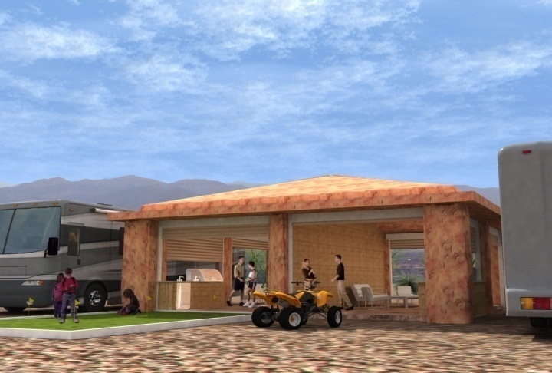All lots will have 200 Amp power service, along with water, sewer. Lot sizes from 40 x 90 or much larger, revolutionary gazebo and outdoor living area, with outdoor kitchens, disappearing commercial grade garage doors and solid FAUX Stone construction. Gazebos may be customized to some degree.

This is a booming industry! We are offering presale discounts. Lots may have rental income potential and large equity gains. Reserve your lot today before the prices increase.

Estimated sellout by end of summer 2010, Estimated total project completion date: Phase 1, summer 2010 or 2011, final Phase 12 months +/- after Phase 1. This is a 1 of a kind opportunity that won't last.

Estimated LOT price: $300,000. +/-

Duner’s with a group of friends, and investors: We will sell in bulk for larger discounts. **Preliminary sales plat is now available.**

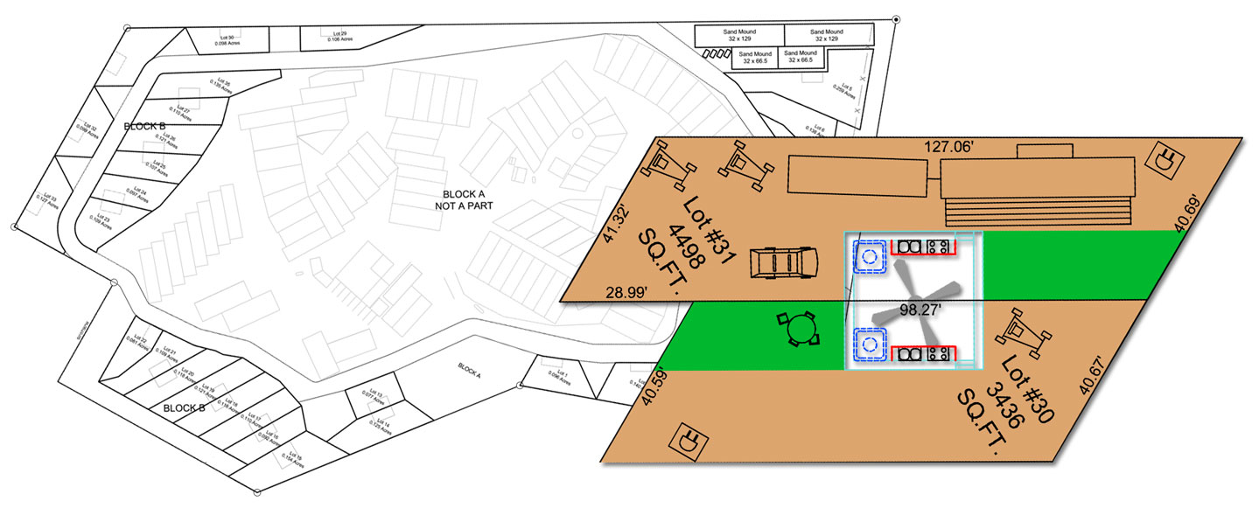



**Sand Hills Resort**

**Near St. Anthony Idaho (Rexburg), abutting the nation’s most popular sand dunes in Fremont County.**

**1-877-789-GROW**

**Sand Hills Resort:**

|  |  |
| --- | --- |
| **Lot uses** | **Summer recreation use. No year round living. No mobile homes or other permanent homes.** |
| **Lot sizes & Access** | **550 to 2,200+/- with Gravel access roads to each lot.** |
| **Terrain** | **Heavily treed with giant mature shade trees and lots of grass. Flat terrain.** |
| **Utilities** | **Some have water, power and sewer, others have water and power.** |
| **Rental Income** | **Ranging from 4% to 8% +/- annual return, not including the annual value appreciation or tax deduction benefits. Very low holding and maintenance costs.** |
| **Miscellaneous** | Managed rental income property in an exploding industry. “DUNE FRONT OWNERSHIP IS MORE VALUABLE THAN WATER FRONT, because it’s almost non-existent” You don’t have to be a “duner” to own a Dune front RV lot with great rental income and unbeatable annual growth! Nightly rental Recreational RV resort for investor and or personal use ownership. The only dune front RV lot ownership in the Nation. Abutting our upcoming luxury Resort which could cause Sand Hills Resort values to climb even faster. Income has increased annually for 30 years, and rental rates have tripled in the last few years. Long and short term benefits of owning a rental property without the typical problems of rental properties is more profitable and these are fully managed. |
| **Management Fee** | **10% of gross rental proceeds (verify current rate).** |
| **Dues** | **$40/mo = $480/yr** |
| **Seller** | **Red Z Inc** |
| **Down Payment** | **Make down payments to Red Z Inc** |

|  |  |  |  |  |  |  |  |
| --- | --- | --- | --- | --- | --- | --- | --- |
| ***Mini Cabins may can be put upon your lot to enhance the usability and rental income! Concrete pads, fire pits, picnic tables, new sod are great ways to upgrade your lot and increase rental income substantially.*** | | | | | | | |
| **P= Pending R=Resell** | | | | | | | |
| **NEW SITE#** | **NOTES** | **UTILITIES** | **LENGTH** | **WIDTH** | **EXACT**  **SQ FT** | **PRICE** | **Pull Thru**  **Or 1 Way** |
| **93** | Great lot in popular shaded cul-de-sac. Surrounded by the biggest trees in the resort. Can be easily upgraded to prime lot. | one-way. partial hook-up lot with water and shared 50/30/20 AMP power w/ Lot 94 | 45 | 20 | 1006 | $24,900 | 1 way |

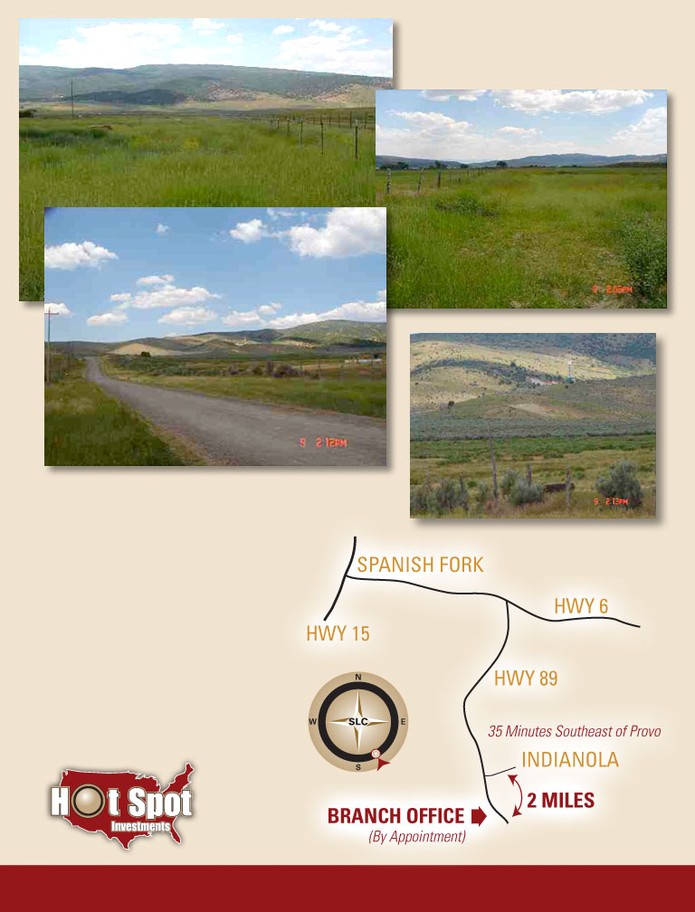

**1-877-789-GROW**

**Indianola Properties**

Indianola, 35 minutes South East of Provo. Sanpete County.

**Major Oil Discovery In Vicinity**

**Near Major Existing Natural Gas Operation**

**PENDING as of 3-16-15**

**Misc. Indianola – 10 Acres**

|  |  |
| --- | --- |
| **Lot uses** | **Agricultural, animal, recreational, year round living and or cabins.** |
| **Access** | **Easily accessible year round. Private gravel access road.** |
| **Terrain** | **Flat terrain. No trees, no sagebrush.** |
| **Utilities** | **Power runs down the West boundary. Old phone line near frontage.** |
| **Water Rights** | **Sold Separately.** |
| **Miscellaneous** | **Stunning valley and mountain views of Skyline Drive. Fully fenced with some cross fencing. $8k in existing road work. New LDS church nearby. Average well depth is approximately 50 to 80 feet. Could be split into 2 5 ac lots.** |
| **Dues** | **None.** |
| **Seller** | **Utahlands.com P.C.** |
| **Down Payment** | **Make down payment to Utahlands.com P.C.** |
| **Price** | **10 acres $119,997** |

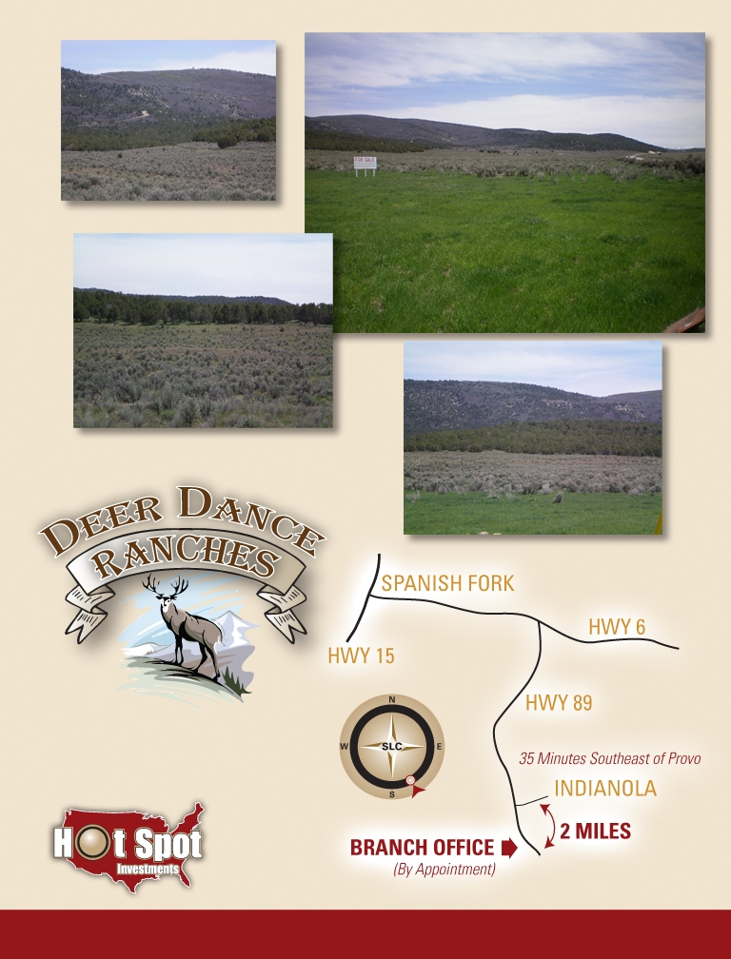**Deer Dance Ranches:**

Indianola, 35 minutes South East of Provo. Sanpete County.

**Major Oil Discovery In Vicinity**

**1-877-789-GROW**

|  |  |
| --- | --- |
| **Lot uses** | **Agricultural, animal, recreational and potential future year round living and or cabins if approved by Sanpete County. Barns, corals, storage buildings, cement pads, etc, can be built.** |
| **Lot sizes** | **5 acre +-** |
| **Access** | **Mostly year round. Paved road frontage to Phase 2. Gravel access roads are under construction.** |
| **Terrain** | **Flat and rolling flat terrain. Terrain is being cleared of sage brush.**  **Private bench settings, flat areas, mild hill areas, heavy tree covered areas.** |
| **Utilities** | **Power, phone and natural gas are near the West boundary of the project.** |
| **Water Rights** | **Sold Separately.** |
| **Miscellaneous** | **Stunning valley and mountain views of Skyline Drive. Some lots have some fencing.**  **Each parcel is surveyed and staked.** |
| **Dues** | **None are currently being routinely billed. Some occasional dues may be billed, $300/year +/-. Eventually the owners will decide what they want to charge for dues, if any.** |
| **Seller** | **Red Z Inc** |
| **Down Payment** | **Make down payments to Red Z Inc** |

**\*\*\*\*\*$15,000 Cash Discount off any 5 acre price shown below.\*\*\*\*\***

**Agricultural Partitioning; At this time, residential/cabin/indoor living construction may not be possible without further approval with Sanpete County. May be able to file a mini subdivision per parcel, to get approved for residential construction, or may be able to file DEEDs for each parcel to create the Tax ID #’s for each parcel, which may allow for residential related construction permits. Agricultural related buildings, garages, barns, sheds, etc are allowed. 200 square foot non-residential structures can be built WITHOUT a building permit.**

|  |  |  |  |  |  |  |
| --- | --- | --- | --- | --- | --- | --- |
| Lot # | Lot Size (acreage) | | Price | Lot # | Lot Size (acreage) | Price |
| 1 | 5.0 trees with camping pad | | **59,997** | 8 | 5.0 | **SOLD** |
| 2 | 5.0 Trees. 800 sq ft Camping Pad included for each section. Build to Suit Pavilions, Mini Cabins, & other upgrades. | | $59,900 (for all sections as 5ac) | 9 | 5.0 | **SOLD** |
| 2a | ½ acre+- | | $14,900 | 10 | 5.0 | **SOLD** |
| **2b** | ½ acre+- | | $14,900 | 11 | 5.01 trees | **SOLD** |
| 2c | ½ acre+- | | $14,900 | 12 | 5.01 | **59,997** |
| 2d | ½ acre+- | | $14,900 | 13 | 5.0 trees | **SOLD** |
| 2e | ½ acre+- | | $14,900 | 14 | 5.41 | **SOLD** |
| 2f | ½ acre+- | | $14,900 | 15 | 5.76 trees | **SOLD** |
| 2g | ½ acre+- | | $14,900 | 16 | 5.0 trees | **SOLD** |
| 2h | ½ acre+- | | $14,900 | 17 | **5.0 trees** | **$59,997** |
| 2i | ½ acre+- | | $14,900 | 18 | **5.0 trees** | **SOLD** |
| 2j | ½ acre+- | | $14,900 | 19 | 5.0 | **SOLD** |
| 3 | 5.0 | **SOLD** | | 20 | 5.79 | **$59,997** |
| 4 | 5.0 | **SOLD** | | 21 | 5.03 | **SOLD** |
| 5 | 5.0 | **SOLD** | | 22 | 5.0 | **SOLD** |
| 6 | **5.0** | **$59,997** | | 23 | 5.76 | **SOLD** |
| 7 | 5.0 | **SOLD** | |  |  |  |

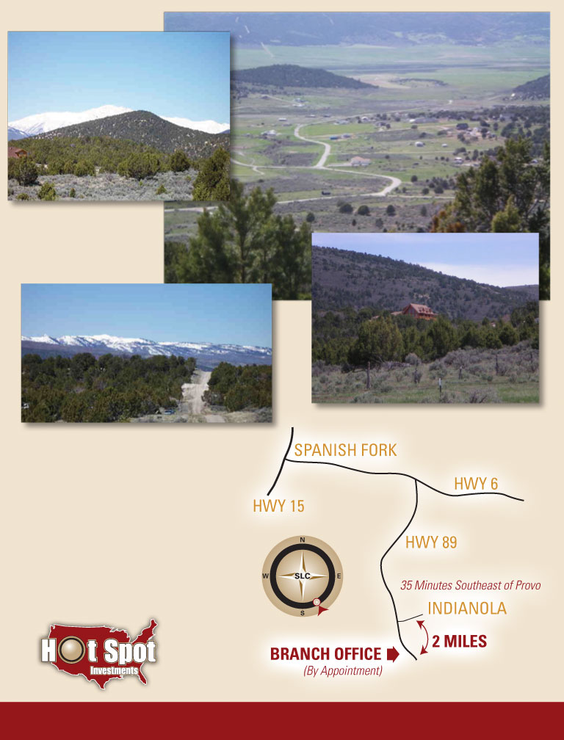

**1-877-789-GROW**

**Hideaway Valley**

Indianola, 35 minutes South East of Provo. Sanpete County.

**Major Oil Discovery**

**In Vicinity**

**Hideaway Valley:**

|  |  |
| --- | --- |
| **Lot uses** | **Year round living, cabin, agricultural, animals and recreational.** |
| **Lot sizes** | **2 to 5 acre lots** |
| **Access** | **Some year round areas and some seasonal areas. Gravel access roads to each lot.** |
| **Terrain** | **Some heavily treed areas and some areas with no trees. Mountain and valley settings.**  **Flat, rolling flat and sloped terrain.** |
| **Utilities** | **Some lots have power and phone, some have no utilities.** |
| **Water Rights** | **Mostly sold Separately.** |
| **Miscellaneous** | **Direct access to Skyline Drive recreation area. Animal rights come with the properties. Spectacular views in this “hidden” community. Average well depth is 150 to 300. Well established community with many homes and cabins.** |
| **Dues** | **As of 2012 dues are approximately $160 per year.** |
| **Seller** | **Mostly Utahlands.com P.C.** |
| **Down Payment** | **Make down payments to applicable seller.** |

**BUILDABLE for Residential and Cabin related structures.**

|  |  |  |  |  |
| --- | --- | --- | --- | --- |
| **Lot#** | **Price** | **Water** | **Owner** | **Terms** |
| **Size** | **Utilities** | | **Notes** | |

|  |  |  |  |  |
| --- | --- | --- | --- | --- |
| **33 B** | **$69,997** | **Available** | **Utahlands (Pending acquisition)** | **Negotiable** |
| **5.00 ac +/-** | **Phone. Power verify.** | | **Must make sale subject to our finalization of acquisition.**  **Great open, flat year-round lot.** | |

|  |  |  |  |  |
| --- | --- | --- | --- | --- |
| **74 B** | **$69,997** | **Available** | **Utahlands** | **Negotiable** |
| **5.00 ac +/-** | **Phone / Power.** | | **Prime building lot. Perfect mix of trees, useable terrain, views and seclusion. Year round access. Nestled at the bottom of the mountain.** | |

|  |  |  |  |  |
| --- | --- | --- | --- | --- |
| **223 C** | **$44,997** | **Available** | **Utahlands** | **Negotiable** |
| **2.41 ac +/-** | **Phone. Power.** | | **Great year round building lot in the private section of Hideaway Valley. Very useable terrain. Trees. Close to mountain trails.** | |

|  |  |  |  |  |
| --- | --- | --- | --- | --- |
| **460 D** | **$49,997** | **Available** | **Utahlands** | **Negotiable** |
| **5.00 ac +/-** |  | | **Awesome view of Milburn Valley. Mostly treed and useable terrain with a perfect open green area. Perfect getaway property. Secluded.** | |

|  |  |  |  |  |
| --- | --- | --- | --- | --- |
| **Possible Repo coming** | | | | |
| **430 D** | **$58,000** | **Available** | **Formen** | **Negotiable** |
| **5.00 ac +/-** |  | | **Nice view lot in the highest section of Hideaway Valley.** | |

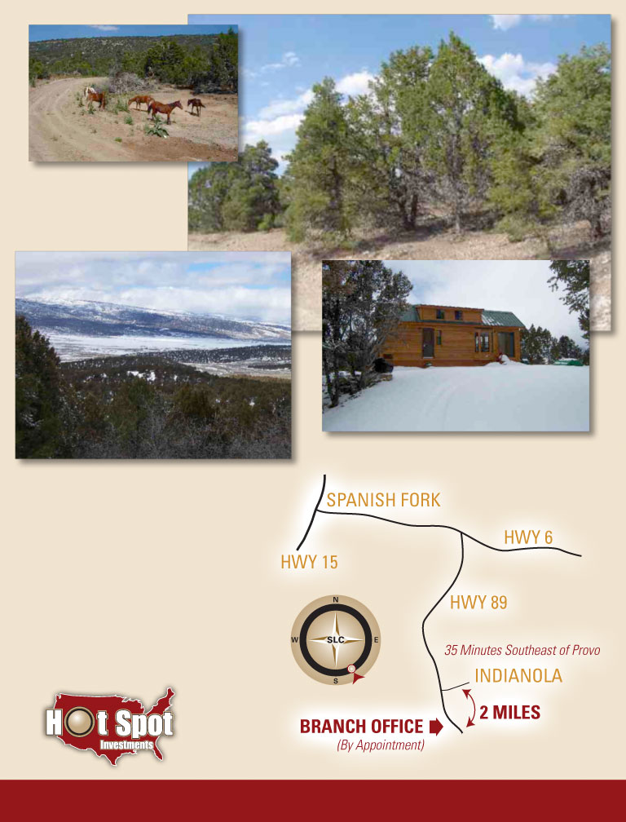

**1-877-789-GROW**

**Elk Horn Ranches**

Indianola, 35 minutes South East of Provo. Sanpete County.

**Major Oil Discovery In Vicinity**

**Elk Horn Ranches**

|  |  |
| --- | --- |
| **Lot uses** | **Agricultural, animal, recreational and potential future year round living and or cabins if approved by Sanpete County. Barns, corals, storage buildings, cement pads, etc, can be built.** |
| **Lot sizes** | **5+ acre lots** |
| **Access** | **Mostly seasonal. Gravel access roads to each lot. Could be year round accessible if desired.** |
| **Terrain** | **Heavily treed with pinion pines and Junipers. Mountain setting.**  **Flat, rolling flat and sloped terrain.** |
| **Utilities** | **No utilities.** |
| **Water Rights** | **Sold Separately.** |
| **Miscellaneous** | **Secluded gated community. Stunning views of the Indianola Valley and Mt Baldy.**  **Prime getaway property, future cabin site, investment and much more.** |
| **Dues** | **None are currently being routinely billed. Some occasional dues may be billed, $100/year +/-. Eventually the owners will decide what they want to charge for dues, if any.** |
| **Seller** | **Elk Horn Agricultural LLC** |
| **Down Payment** | **Make down payments to Elk Horn Agricultural L.C.** |

**Agricultural Partitioning; At this time, residential/cabin/indoor living construction may not be possible without further approval with Sanpete County. May be able to file a mini subdivision per parcel, to get approved for residential construction, or may be able to file DEEDs for each parcel to create the Tax ID #’s for each parcel, which may allow for residential related construction permits. Agricultural related buildings, garages, barns, sheds, etc are allowed. 200 square foot non-residential structures can be built WITHOUT a building permit.**

|  |  |  |  |  |  |  |
| --- | --- | --- | --- | --- | --- | --- |
| **Lot #** | **Lot Size (acreage)** | **Price** | **Lot #** | **Lot Size (acreage)** | | **Price** |
| **1** | **5.00** | **SOLD** | **13** | **5.70 sloped/view** | | **Pending** |
| **2** | **5.00** | **SOLD** | **14** | **5.75** | | **SOLD** |
| **3** | **5.00 Driveway, Camping Pad, 8X8 ft cabin shed. Must sell w/ easement.** | **$59,997** | **15** | **5.40**  **Includes Camping Pad** | | **SOLD** |
| **4** | **5.00** | **SOLD** | **16** | **5.00** | | **SOLD** |
| **5** | **6.28** | **SOLD** | **17** | **5.70** | **$59,997 Pending**  **Retain Well Easement, Put “See Exhibit A” on REPC** | |
| **6** | **5.01 Includes septic tank and camping pad(s)** | **Pending** | **18** | **5.214** | | **SOLD** |
| **7** | **5.01** | **$59,997** | **19** | **5.49** | | **Pending as of 3-16-15 $59,997** |
| **8** | **5.00** | **SOLD** | **20** | **5.17**  **Includes Camping Pad** | | **SOLD** |
| **9** | **5.07** | **SOLD** | **21** | **5.21** | | **SOLD** |
| **10** | **5.26** | **SOLD** | **22** | **5.00**  **Includes Camping Pad** | | **SOLD** |
| **11** | **5.05** | **SOLD** | **23** | **5.07**  **Includes Camping Pad** | | **SOLD** |
| **12** | **5.15** | **SOLD** |  |  | |  |

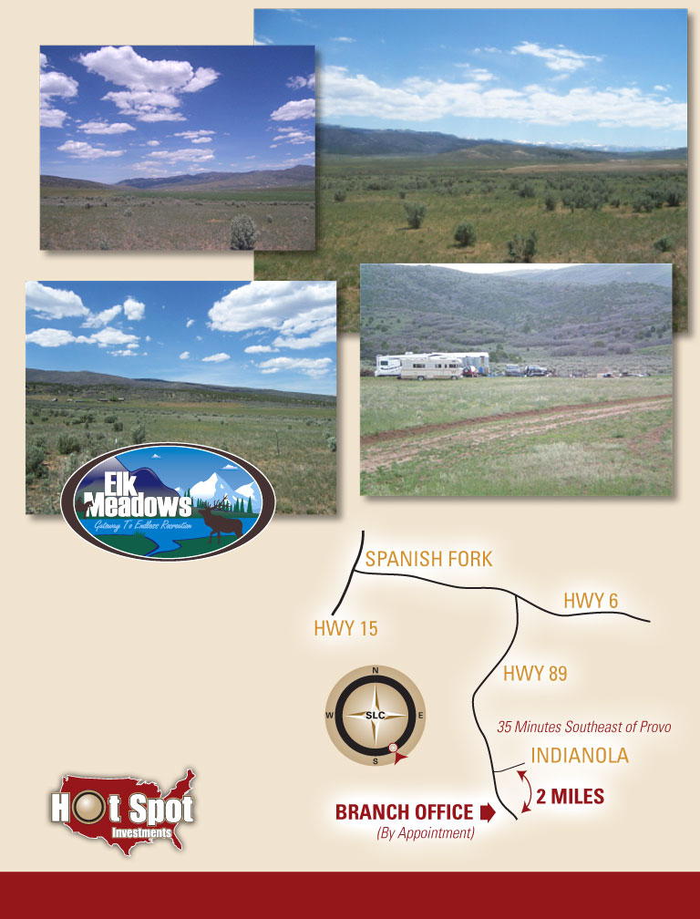

**1-877-789-GROW**

**Elk Meadows**

Indianola, 35 minutes South East

of Provo. Sanpete County.

**Major Oil Discovery In Vicinity**

**Elk Meadows**

|  |  |
| --- | --- |
| **Lot uses** | **Agricultural, animal, recreational and potential future year round living and or cabins if approved by Sanpete County. Barns, corals, storage buildings, cement pads, etc, can be built.** |
| **Lot sizes** | **5 to 7.99 acre** |
| **Access** | **Mostly year round. Gravel access roads to each lot.** |
| **Terrain** | **Flat and rolling flat terrain. Terrain has been de-rocked, cleared of sage brush and tilled.**  **Private bench setting.** |
| **Utilities** | **No utilities. Power is near the North boundary of the project.** |
| **Water Rights** | **Sold Separately.** |
| **Miscellaneous** | **Stunning valley and mountain views of Skyline Drive. Some lots have some fencing.**  **Each parcel has been surveyed and staked. Private bench location at the bottom of the Mountain.** |
| **Dues** | **None are currently being routinely billed. Some occasional dues may be billed, $100/year +/-. Eventually the owners will decide what they want to charge for dues, if any.** |
| **Seller** | **Red Z Inc** |
| **Down Payment** | **Make down payments to Red Z Inc** |

**\*\*\*\*\*$15,000 Cash Discount off any 5 acre price shown below.\*\*\*\*\***

**Agricultural Partitioning; At this time, residential/cabin/indoor living construction may not be possible without further approval with Sanpete County. May be able to file a mini subdivision per parcel, to get approved for residential construction, or may be able to file DEEDs for each parcel to create the Tax ID #’s for each parcel, which may allow for residential related construction permits. Agricultural related buildings, garages, barns, sheds, etc are allowed. 200 square foot non-residential structures can be built WITHOUT a building permit.**

|  |  |  |  |  |  |
| --- | --- | --- | --- | --- | --- |
| **Lot #** | **Lot Size (acreage)** | **Price** | **Lot #** | **Lot Size (acreage)** | **Price** |
| **1** | **5.52** | **Pending, Jon, Meat w/ Us** | **18** | **10 Not Ours; Lamont’s** | **SOLD** |
| **2** | **5.51** | **SOLD** | **19** | **6.61** | **$69,997** |
| **3** | **5.50** | **$59,997** | **20** | **7.366** | **$74,997** |
| **4** | **5.50** | **SOLD** | **21** | **5.50** | **SOLD** |
| **5** | **5.00** | **SOLD** | **22** | **5.50** | **$59,997** |
| **6** | **5.50** | **SOLD** | **23** | **5.50** | **SOLD** |
| **7** | **5.50** | **$59,997** | **24** | **5.50** | **SOLD** |
| **8** | **5.50** | **SOLD** | **25** | **5.50** | **SOLD** |
| **9** | **5.50** | **SOLD** | **26** | **5.50** | **SOLD** |
| **10** | **5.50** | **SOLD** | **27** | **5.50** | **$59,997** |
| **11** | **7.99** | **$79,997** | **28** | **5.50** | **$59,997** |
| **12** | **7.31** | **$74,997** | **29** | **5.50** | **SOLD** |
| **13** | **5.68** | **$59,997** | **30** | **5.74** | **$59,997** |
| **14** | **5.51** | **$59,997** | **31** | **5.51** | **SOLD** |
| **15** | **5.50** | **$59,997 Retain well easement, put “ see exhibit A” on REPC** | **32** | **5.00** | **$59,997** |
| **16** | **5.91** | **SOLD** | **33** | **5.50** | **$59,997** |
| **17** | **5.74** | **SOLD** |  |  |  |

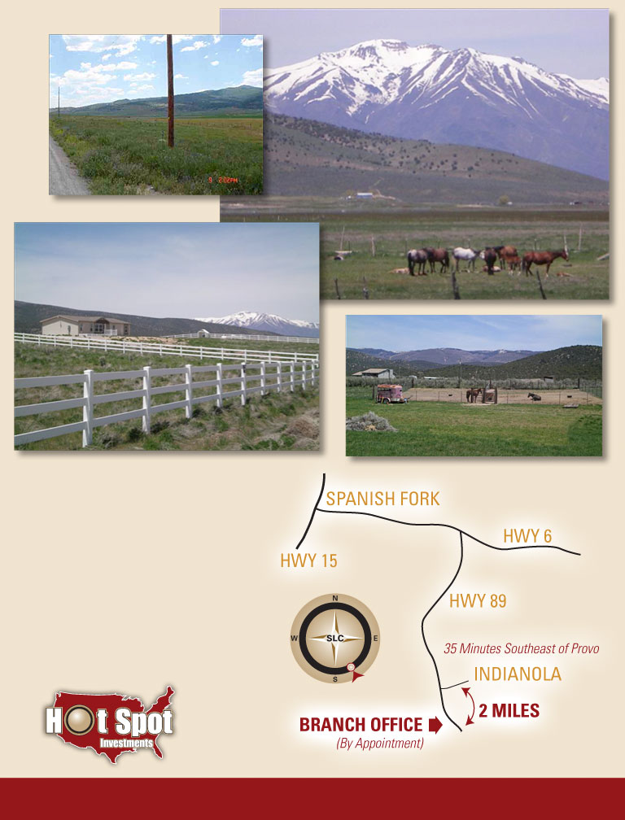**Fairview Ranchos II**

**Fairview Ranchos II**

Indianola, 35 minutes South East of Provo. Sanpete County.

**Major Oil Discovery In Vicinity**

**1-877-789-GROW**

|  |  |
| --- | --- |
| **Lot uses** | **Year round living, cabin, agricultural, animal and recreational.** |
| **Lot sizes** | **2 to 5 acre lots** |
| **Access** | **Year round gravel access roads to each lot.** |
| **Terrain** | **Valley setting. Flat and rolling flat terrain.** |
| **Utilities** | **Power and phone in front of each lot.** |
| **Water Rights** | **Sold Separately.** |
| **Miscellaneous** | **Stunning views of Mt Baldy and Skyline Drive. Some lots have some fencing. Each parcel has been surveyed and staked. Average well depth is 135. 360˚ views. Established community.** |
| **Dues** | **None are currently being routinely billed. Some occasional dues may be billed, $100/year +/-. Eventually the owners will decide what they want to charge for dues, if any.** |
| **Seller** | **Fairview Ranchos II LLC** |
| **Down Payment** | **Make down payments to Fairview Ranchos II LLC** |

***NOTES:***

**Lot 15 owner is willing to negotiate & sell well connections or water usage from their existing well.**

**Terms are supposed to be 8% interest and no more than 15 year loans; may be negotiable.**

**Pricing shown is after all match & repo client equity voucher credits per temporary 50% +/- price reductions. Water available for $10,000 per acre foot. Only .75 ac ft is required for building permit in Phases I and II (Buyer should verify.)**

**BUILDABLE for Residential and Cabin related structures.**

|  |  |  |  |
| --- | --- | --- | --- |
| **Lot#** | **Price** | **Size** | **Water Sold Separately .75 ac ft = $7,500 & .9 ac ft = $9,000 FIRM** |

|  |  |  |  |
| --- | --- | --- | --- |
| **5** | **$59,997** | **3.4 ac** | **Sue to insert** |

|  |  |  |  |
| --- | --- | --- | --- |
| **8** | **57,997** | **3.19 ac** | **Sue to insert** |

|  |  |  |  |
| --- | --- | --- | --- |
| **11** | **69,497** | **4.17** | **Sue to insert** |

|  |  |  |  |
| --- | --- | --- | --- |
| **12** | **67,997** | **4.07** | **Sue to insert** |

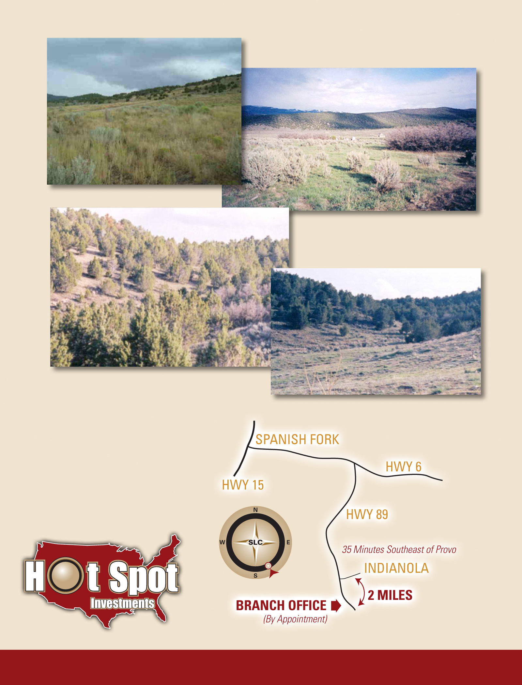

**Oaker Hills Ranches**

Indianola, 35 minutes South East of Provo. Sanpete County.

**Major Oil Discovery In Vicinity**

**1-877-789-GROW**

**1-877-789-GROW**

**Oaker Hills**

|  |  |
| --- | --- |
| **Lot uses** | **Agricultural, animal, recreational, year round living and cabins.** |
| **Lot sizes** | **5+ acre lots** |
| **Access** | **Year round gravel access roads to most lots.** |
| **Terrain** | **Some heavily treed areas and some areas have no trees. Mountain and valley setting.**  **Flat, rolling flat and sloped terrain.** |
| **Utilities** | **Phone to each lot. Power runs along the South boundary of the project.** |
| **Water Rights** | **.25 acre foot included with most lots.** |
| **Miscellaneous** | **Gated community. Very private. Spectacular views. Each parcel has been surveyed and staked.**  **Average well depth is 150 to 300.** |
| **Dues** | **Approximately $250/year.** |
| **Seller** | **Miscellaneous.** |
| **Down Payment** | **Make down payments to Applicable owner listed below.** |

|  |  |  |  |  |
| --- | --- | --- | --- | --- |
| **Lot#** | **Price** | **Water** | **Owner** | **Terms** |
| **Size** | **Utilities** | | **Notes** | |

|  |  |  |  |  |
| --- | --- | --- | --- | --- |
| **146 P1** | **$59,900** | **Available** | **Utahlands, pending acquisition** | **Negotiable** |
| **5.00 ac +/-** | **Power and Phone.** | | **Flat. Nice grassy lot with a few small oak trees. Water wells in this area of the project are more shallow.** | |

**Westridge Farms**

Indianola, 35 minutes South East of Provo. Sanpete County.

**Major Oil Discovery In Vicinity**

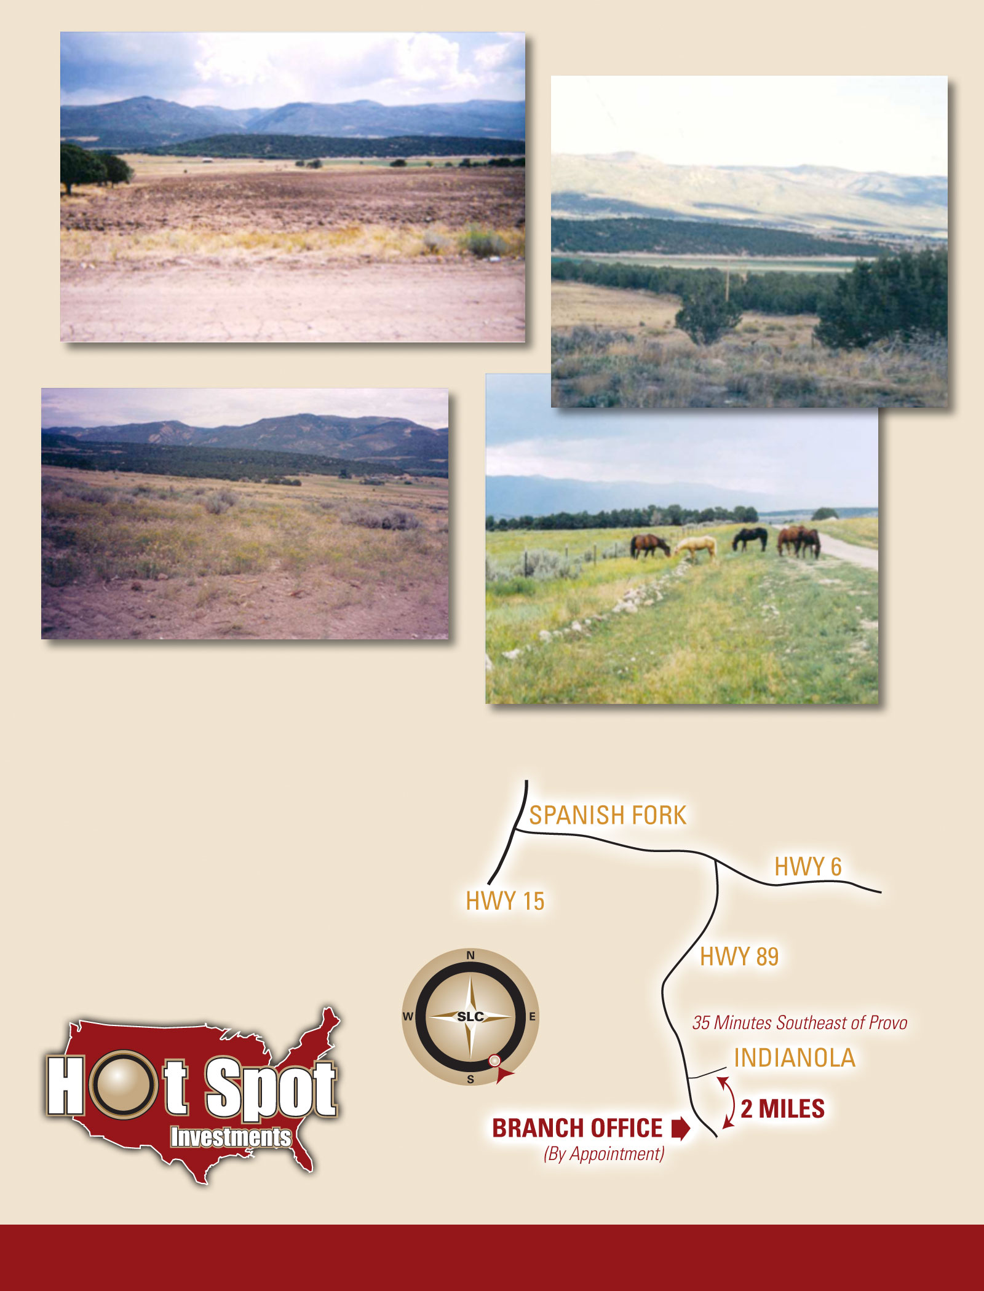

**1-877-789-GROW**

**1-877-789-GROW**

**Westridge Farms**

|  |  |
| --- | --- |
| **Lot uses** | **Agricultural, animal, recreational and potential future year round living and or cabins if approved by Sanpete County. Barns, corals, storage buildings, cement pads, etc, can be built.** |
| **Lot sizes** | **5+ acre** |
| **Access** | **Could easily be year round accessible. Gravel access roads to each lot.** |
| **Terrain** | **Flat and rolling flat terrain. Terrain has been de-rocked, cleared of sage brush and tilled.** |
| **Utilities** | **Power has been run to the project.** |
| **Water Rights** | **Sold Separately. A pressurized irrigation line runs through the project.** |
| **Miscellaneous** | **Stunning valley and mountain views of Skyline Drive. Some lots have some fencing.**  **Each parcel has been surveyed and staked. Very secluded. Near City boundary for annexation. Currently within a 1 acre zoning for prime development.** |
| **Dues** | **None are currently being routinely billed. Some occasional dues may be billed, $100/year +/-. Eventually the owners will decide what they want to charge for dues, if any.** |
| **Seller** | **Red Z Inc** |
| **Down Payment** | **Make down payments to Red Z Inc** |

**\*\*\*\*\*$15,000 Cash Discount off any 5 acre price shown below.\*\*\*\*\***

**Agricultural Partitioning; At this time, residential/cabin/indoor living construction may not be possible without further approval with Sanpete County. May be able to file a mini subdivision per parcel, to get approved for residential construction, or may be able to file DEEDs for each parcel to create the Tax ID #’s for each parcel, which may allow for residential related construction permits. Agricultural related buildings, garages, barns, sheds, etc are allowed. 200 square foot non-residential structures can be built WITHOUT a building permit.**

|  |  |  |  |  |
| --- | --- | --- | --- | --- |
| **Lot#** | **Price** | **Water** | **Owner** | **Terms** |
| **Size** | **Utilities** | | **Notes** | |

|  |  |  |  |  |
| --- | --- | --- | --- | --- |
| **1** | **$59,900** | **Separate/$10k cash or terms** | **Red Z Inc** | **Negotiable** |
| **5.84** | **Power nearby.** | **Unbeatable views of Skyline Dr, Fairview City, etc. Great flat recreation or potential building lot.** | | |

|  |  |  |  |  |
| --- | --- | --- | --- | --- |
| **2** | **$69,900** | **Separate/$10k cash or terms** | **Red Z Inc** | **Negotiable** |
| **6.73** | **Power nearby.** | **Unbeatable views of Skyline Dr, Fairview City, etc. Great flat recreation or potential building lot.** | | |

|  |  |  |  |  |
| --- | --- | --- | --- | --- |
| **6** | **$59,900** | **Separate/$10k cash or terms** | **Red Z Inc** | **Negotiable** |
| **5.25** | **Power nearby.** | **Unbeatable views of Skyline Dr, Fairview City, etc. Great flat recreation or potential building lot.** | | |

|  |  |  |  |  |
| --- | --- | --- | --- | --- |
| **7** | **$59,900** | **Separate/$10k cash or terms** | **Red Z Inc** | **Negotiable** |
| **5.25** | **Power nearby.** | **Unbeatable views of Skyline Dr, Fairview City, etc. Great flat recreation or potential building lot.** | | |

**Whispering Pines**

|  |  |
| --- | --- |
| **Lot uses** | **Year round living, cabin, RV’s allowed for summer season April 1 to Oct 31.** |
| **Lot sizes** | **1.0 ac** |
| **Access** | **Year round access with snow removal, Gravel roads to each lot (4 wheel drive recommended)** |
| **Terrain** | **Flat lot with trees.** |
| **Utilities** | **All lots have power to the lot, Rocky Mt Power Co will do meter, water connection to lot, trash collection available for $14 per mo.** |
| **Water Rights** | **WP has its own water system, Water certificate comes with lot & $100 transfer fee, usage $297 per yr when connected ($127 per yr as is)** |
| **Miscellaneous** | **Laid back rural mountain gated community located 6 mi southeast of Mt Pleasant just off Highway 89. Manti LaSal National Forest nearby with 4 wheeling, hiking, snowmobiling, and camping. Skyline Dr 20 min away up Fairview Canyon. Famous Maple Canyon 30 min away for the rock climbing enthusiast. Clean air, picturesque views, and NO traffic.** |
| **Dues** | **Property Owner’s Association with $85 Annual Dues (Snow removal included with dues)** |
| **Seller** | **Listed with Hot Spot Realty by Jamison Cy Smith, 801-599-8982** |
| **Financing** | **Seller Financing Available** |

**BUILDABLE for Residential and Cabin related structures.**

|  |  |  |  |  |
| --- | --- | --- | --- | --- |
| **Lot#** | **Price** | **Water** | **Owner** | **Terms** |
| **Size** | **Utilities** | | **Notes** | |

|  |  |  |  |  |
| --- | --- | --- | --- | --- |
| **167 A** | **$18,900** | **Water Included** | **Jerald Hunsaker** | **10% down, 15 year Term+-.** |
| **1.0 ac** | **Water & Power. Phone?** | **Prime lot located in a rural mountain area, moderately treed lot. Great quiet community for year round or recreation. Nice access roads.** | | |

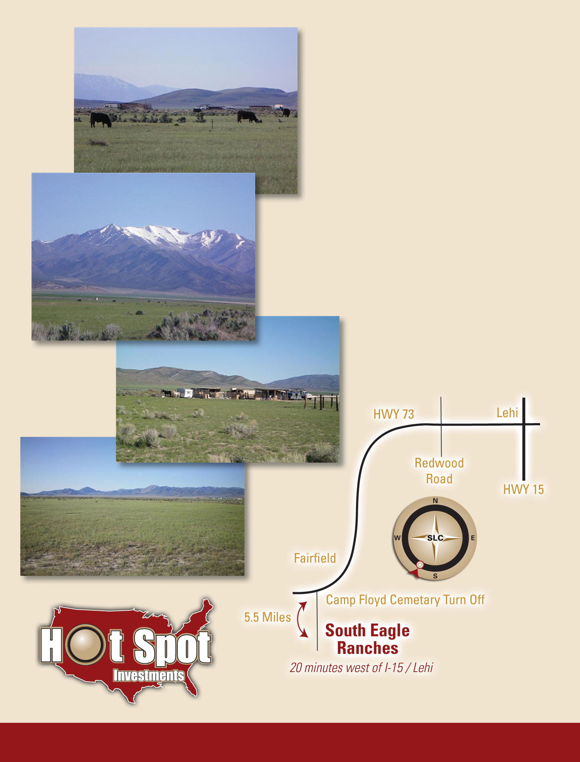

**Fairfield Farms**

**Fairfield Farms**

Fairfield, 20 minutes West of Lehi, Utah County.

**1-877-789-GROW**

**Fairfield Farms**

|  |  |
| --- | --- |
| **Lot uses** | **Agricultural, animal, recreational and potential future year round living in the distant future. Barns, corals, storage buildings, cement pads, etc, can be built on the parcels.** |
| **Lot sizes** | **5+ acre** |
| **Access** | **Year round gravel access roads to each lot.** |
| **Terrain** | **Flat terrain. Some areas have sage brush some have very little sage.** |
| **Utilities** | **No utilities.** |
| **Water Rights** | **Sold Separately.** |
| **Miscellaneous** | **Amazing 360 degree views. Some lots have some fencing. Each parcel has been surveyed and staked. Average well depth in the Cedar Valley area is about 300 foot. Agricultural and other recreational use. Extremely flat terrain** |
| **Dues** | **None are currently being routinely billed. Some occasional dues may be billed, $100/year +/-. Eventually the owners will decide what they want to charge for dues, if any.** |
| **Taxes** | **Currently $0 annual Buyer cost; we pay the few dollars tax per year, due to Greenbelt reduction.** |
| **Seller** | **Utahlands.com P.C.** |
| **Down Payment** | **Make down payments to Utahlands.com P.C.** |

**NOTES: Agricultural only. No residential or cabin related structures allowed at this time. As zoning changes and city expands, this potential for building residential related structures will change.**

**Water well access may be available for each lot, as negotiated.**

|  |  |  |  |  |
| --- | --- | --- | --- | --- |
| **Lot#** | **Price** | **Water** | **Owner** | **Terms** |
| **Size** | **Utilities** | | **Notes** | |

|  |  |  |  |  |
| --- | --- | --- | --- | --- |
| **16** | **$59,900** | **Sold separate: Available: $15,000/ac ft** | **Utahlands.com P.C. (Fred/Don…)** | **Negotiable** |
| **5+/- ac** | **None at this time** | | **Some fencing, flat, animal rights.** | |



**South Eagle Ranches**

Fairfield, 20 minutes West of Lehi,

Utah County.

**1-877-789-GROW**

**South Eagle Ranches**

|  |  |
| --- | --- |
| **Lot uses** | **Agricultural, animal, recreational and potential future year round living in the distant future. Barns, corals, storage buildings, cement pads, etc, can be built on the parcels.** |
| **Lot sizes** | **5+ acre** |
| **Access** | **Year round gravel access roads to each lot.** |
| **Terrain** | **Flat terrain. Some areas have sage brush some have very little sage.** |
| **Utilities** | **No utilities.** |
| **Water Rights** | **Sold Separately.** |
| **Miscellaneous** | **Amazing 360 degree views. Some lots have some fencing. Each parcel has been surveyed and staked. Average well depth in the Cedar Valley area is about 300 foot. Agricultural and other recreational use. Extremely flat terrain** |
| **Dues** | **None are currently being routinely billed. Some occasional dues may be billed, $100/year +/-. Eventually the owners will decide what they want to charge for dues, if any.** |
| **Taxes** | **Currently $0 annual Buyer cost; we pay the few dollars tax per year, due to Greenbelt reduction.** |
| **Seller** | **Utahlands.com P.C.** |
| **Down Payment** | **Make down payments to Utahlands.com P.C.** |

**NOTES: Agricultural only. No residential or cabin related structures allowed at this time. As zoning changes and city expands, this potential for building residential related structures will change.**

**Water well access available as negotiated.**

|  |  |  |  |  |
| --- | --- | --- | --- | --- |
| **Lot#** | **Price** | **Water** | **Owner** | **Terms** |
| **Size** | **Utilities** | | **Notes** | |

**More lots coming soon**

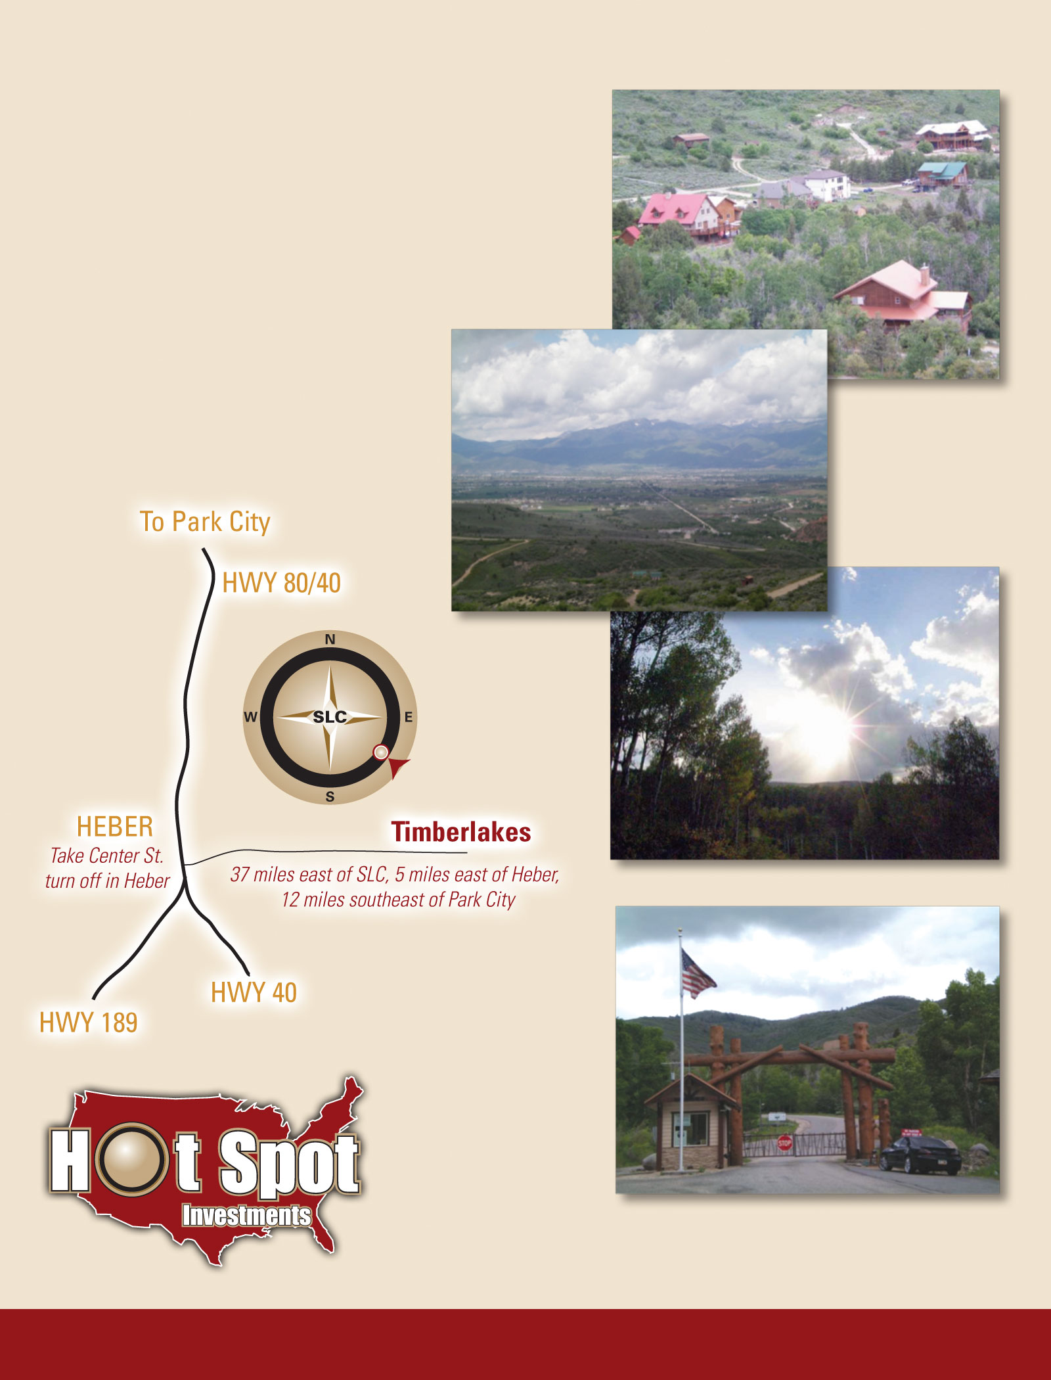

**Timberlakes**

**Timberlakes**

5 minutes East of Heber,

Wasatch County.

**1-877-789-GROW**

|  |  |
| --- | --- |
|  | **Year round living, cabin and recreational. RV’s only allowed while constructing home/cabin.** |
| **Lot sizes** | **1+ acre lots** |
| **Access** | **Year round access to some lots, others may be accessed by 4 wheel drive. Some paved roads.** |
| **Terrain** | **Mountain setting. Mild slopes, bench areas, some flat areas, some steep slopes.** |
| **Utilities** | **Water and power to many lots.** |
| **Miscellaneous** | **Gorgeous gated mountain community just a 7 miles East of Heber. Tree coverage in many areas. Unbeatable views. Some paved road frontage. Recreation dream close to Jordanell Reservoir and endless snowmobiling and ATV trails. No animal rights.** |
| **Dues, water, taxes** | **As of 2-1-13; Water bill: $40 to $68.95 /month. Dues: $715/year. Taxes: $150+- /year.** |
| **Seller** | **Utahlands.com P.C.** |
| **Down Payment** | **Make down payments to Utahlands.com P.C.** |

**BUILDABLE for Residential and Cabin related structures.**

**Pricing shown is after all match & repo client equity voucher credits per temporary price reductions. Cash pricing shown, ask for Seller Financed price.**

|  |  |  |  |  |
| --- | --- | --- | --- | --- |
| **Lot#** | **Price** | **Water** | **Owner** | **Terms** |
| **Size** | **Utilities** | | **Notes** | |

|  |  |  |  |  |
| --- | --- | --- | --- | --- |
| **1427** | **$44,997** | **Available** | **Utahlands.com P.C.** | **Negotiable** |
| **1 ac  +/-** | Has Water. Power 600 ft+/- | On year round snow plow route. Beautiful mountain setting, need to excavate useable terrain, secluded. Sloped BUT next to Creek! Move fill to lot 266! Needs perc test. 1789 S Beaver Bench Rd Heber City Ut 84032 | | |

|  |  |  |  |  |
| --- | --- | --- | --- | --- |
| **1351** | **$44,997** | **Available** | **Utahlands.com P.C.** | **Negotiable** |
| **1 ac +/-** | Has water. 100+/- ft from Pwr/Phn | On year round snow plow route. Beautiful mountain setting, secluded. Oak trees. Medium slope, perfect view lot with Northern exposure. Spring nearby. Perc test passed but septic tank may need to be located in a different spot. 2381 South Westview Dr Heber City Ut 84032 | | |

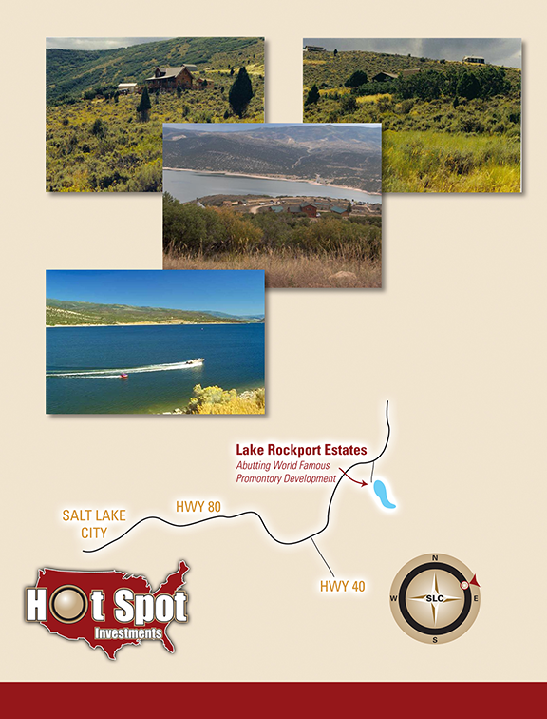

**1-877-789-GROW**

**Lake Rockport Estates**

30 minutes east of Salt Lake City

**Summit County**

**Approximately 15 minutes to Park City**

**Lake Rockport Estates -**

|  |  |
| --- | --- |
| **Lot uses** | **Year round living, cabin and rec/RV’s can stay summer season until Oct, then relocated on lot.** |
| **Lot sizes** | **1+ acre lots** |
| **Access** | **Year round access to some lots, others may be accessed by 4 wheel drive. Gravel Roads.** |
| **Terrain** | **Mountain Setting. Some flat and rolling terrain, mostly sloped.** |
| **Utilities** | **Water and power to many lots.** |
| **Miscellaneous** | **Gorgeous gated mountain community abutting World Famous Promontory Club Development near Park City Utah. Tree coverage in some areas. Unbeatable view of Lake Rockport. Recreation dream across from Rockport Reservoir, close to Jordanell Reservoir, World Famous Utah Skiing and endless snowmobiling and ATV trails. No animal rights.** |
| **Dues, water, taxes** | **As of 8-1-09 annual dues are $630/year.** **As of 6-2014, the water is turned on from May 1st through October 31st.**  **Water wells can be drilled in Lake Rockport Estates.**  **Weber Basin leases water rights for drilling wells.**  **Well depths vary. Newest well drilled in 2014 for the POA was about 600 foot, located by lot 15. 90 Gallons Per Minute (GPM).**  **There is a new official POA plan in motion, to convert the water use to year round, within 24 years, or likely less as they optimize the overall plan, budget, etc.** |
| **Seller** | **Red Z Inc** |
| **Down Payment** | **Make down payments to Red Z Inc** |

**BUILDABLE for Residential and Cabin related structures.**

**Pricing shown is after all match & repo client equity voucher credits per temporary 50% price reductions.** Cash pricing shown

|  |  |  |  |  |
| --- | --- | --- | --- | --- |
| **Lot#** | **Price** | **Water** | **Owner** | **Terms** |
| **Size** | **Utilities** | | **Notes** | |

|  |  |  |  |  |
| --- | --- | --- | --- | --- |
| **301** | **44,997** | **Water Connection available** | **Red Z Inc** | **Negotiable** |
| **1 ac +/-** | Power 1 lot away, Water | Beautiful mountain setting with a view of Rockport Reservoir. Lots of useable and buildable terrain. This lot is on top of the mountain, viewing Park City Ski Slopes. Very secluded. Graveled road access. Some areas are year round maintained, would need to verify year round access for this lot, but owners can plow the roads. May have partial lake view, need to verify. | | |

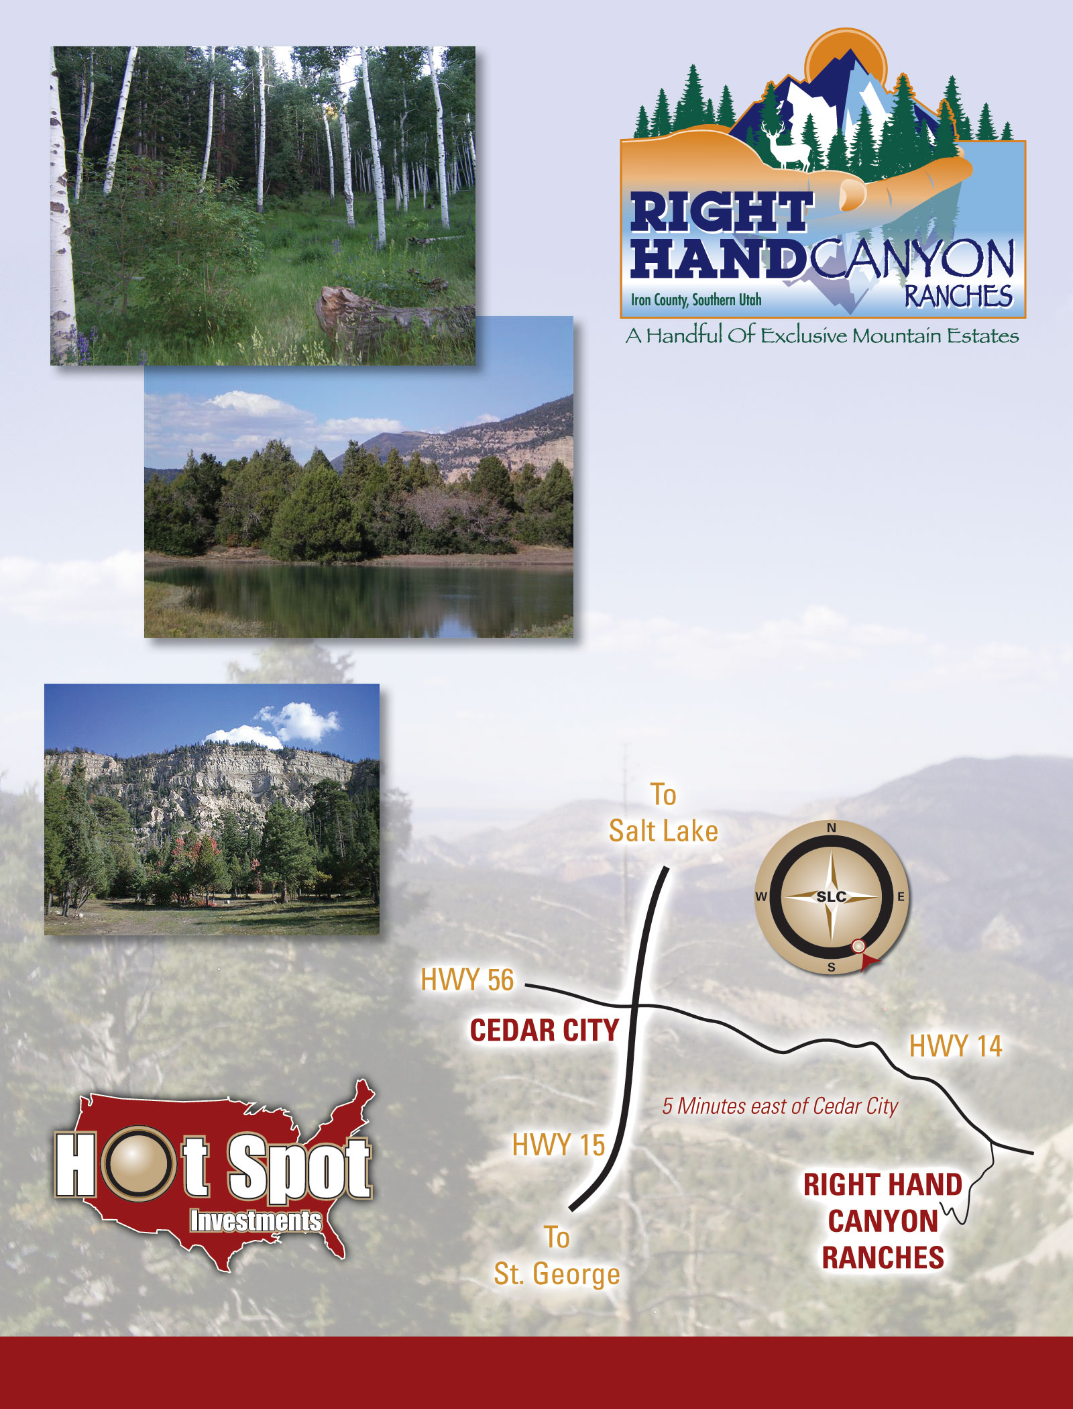

**Right Hand Canyon -**

**1-877-789-GROW**

**45 minutes North of St. George,**

**3 hours from Las Vegas. Iron County.**

**www.OwnTheMt.com**

**1-877-789-GROW**

|  |  |
| --- | --- |
| **Lot uses** | **Investment grade Mountain Estates. Year round living potential per consensus of POA, prime cabin lots and recreational use.** |
| **Lot sizes** | **22 to 354 acres** |
| **Access** | **Gated seasonal gravel road access until otherwise converted to year round by the POA.** |
| **Terrain** | **Heavily treed in old growth forestry. Varied elevations. Large flat meadows, sloped view areas. Mountain and valley settings. Flat, rolling flat and sloped terrain.** |
| **Utilities** | **Existing overhead power line to some lots, Private water line to all lots(construction pending).** |
| **Miscellaneous** | **This private getaway is nestled 10 minutes East of Cedar City, just a few minutes away yet in a world of its’ own. Each mountain estate will provide a unique paradise surrounded by endless recreation, cool and fresh air, mature forestry, tireless views and the comfort of being surrounded by likeminded individuals looking for a secluded upscale mountain retreat.** |
| **Dues** | **To be determined, if any, by POA.** |
| **Seller** | **Right Hand Canyon Ranches LLC** |
| **Down Payment** | **Make down payments to Right Hand Canyon Ranches LLC or Southern Utah Title Co.** |

**Pricing shown is after all match & repo client equity voucher credits.**

|  |  |  |  |
| --- | --- | --- | --- |
| **Lot #** | **Lot Size** | **Price** | **Lot Description** |
| **Utilities** |

|  |  |  |  |
| --- | --- | --- | --- |
| **Lot 1** | **22.55 ac** | **$599,000** | Own the top of the Hill! Fully covered in Pinion Pine and Juniper trees with some Oak. Pond View. Hilly with some gradual slope terrain. Crosses large ravine. |
| **Pwr, Wtr** |

|  |  |  |  |
| --- | --- | --- | --- |
| **Lot 2** | **22.28 ac** | **$599,000** | Spring fed pond. Flat open meadows and Gamble Oak Grove abutting pond. Mostly covered in Pinion Pine and Juniper trees with some Oak and Ponderosa. Mild terrain and slope where it crosses ravine. |
| **Pwr, Wtr** |

|  |  |  |  |
| --- | --- | --- | --- |
| **Lot 3** | **28.15ac** | **$599,000** | Large flat meadow with pond view and privacy from surrounding mountain sides. Major change in elevation from bottom flat area to top of the hill to the South. Mostly covered in Pinion Pine and Juniper trees with some Oak. |
| **Pwr, Wtr** |

|  |  |  |  |
| --- | --- | --- | --- |
| **Lot 4** | **26.34 ac** | **$599,000** | Excellent views. Mostly covered in Pinion Pine, Juniper and Oak trees plus some Ponderosa Pines. Generally flat usable area at the top of the hill. Major change in elevation downhill to the North. |
| **Pwr, Wtr** |

|  |  |  |  |
| --- | --- | --- | --- |
| **Lot 5** | **122.35ac** | **$1,900,000** | Many elevation changes. Unbeatable views. Rock ledges. Pond views. Pinion Pine, Juniper and Oak trees. Can be further subdivided. Many private cabin site locations. TO be developed by RHCR LLC unless SOLD as one piece. |
| **Water** |

|  |  |  |  |
| --- | --- | --- | --- |
| **Lot 6** | **23.91 ac** | **$599,000** | Private flat meadow. Incredible views. Miscellaneous tree coverage including Pinion Pine, Cedar, Ponderosa Pine, Douglas Fir, Oak. PRIME LOT. |
| **Water** |

|  |  |  |  |
| --- | --- | --- | --- |
| **Lot 7** | **23 ac** | **$599,000** | 360˚ views including Cedar Breaks. Large flat cabin site already excavated, plus driveway. Miscellaneous tree coverage including Douglas Fir, Pinion Pine, Juniper, Oak, etc. Natural rock and cliff scenery in your backyard. PRIME LOT. |
| **Water** |

|  |  |  |  |
| --- | --- | --- | --- |
| **Lot 8** | **27.23 ac** | **$599,000** | The best tree coverage available, including Douglas Fir, Pinion Pine, Juniper, Oak, etc. 200+/- ft cliffs in your backyard. Views to die for. Large flat cabin site already excavated, plus driveway. PRIME LOT. |
| **Water** |

|  |  |  |  |
| --- | --- | --- | --- |
| Lot 9 | 354.45 ac | $5.4 Million | The best tree coverage available, including Blue Spruce, Ponderosa Pine, Quaking Aspen, Douglas Fir, Pinion Pine, Juniper, Oak, etc. 200+/- ft cliffs in your backyard. Views to die for. . Driveway to huge meadow and numerous large flat cabin sites. Springs on lot. Various improved roads throughout. PRIME LOT. May have subdivision potential. |
| **Pwr, Wtr** |

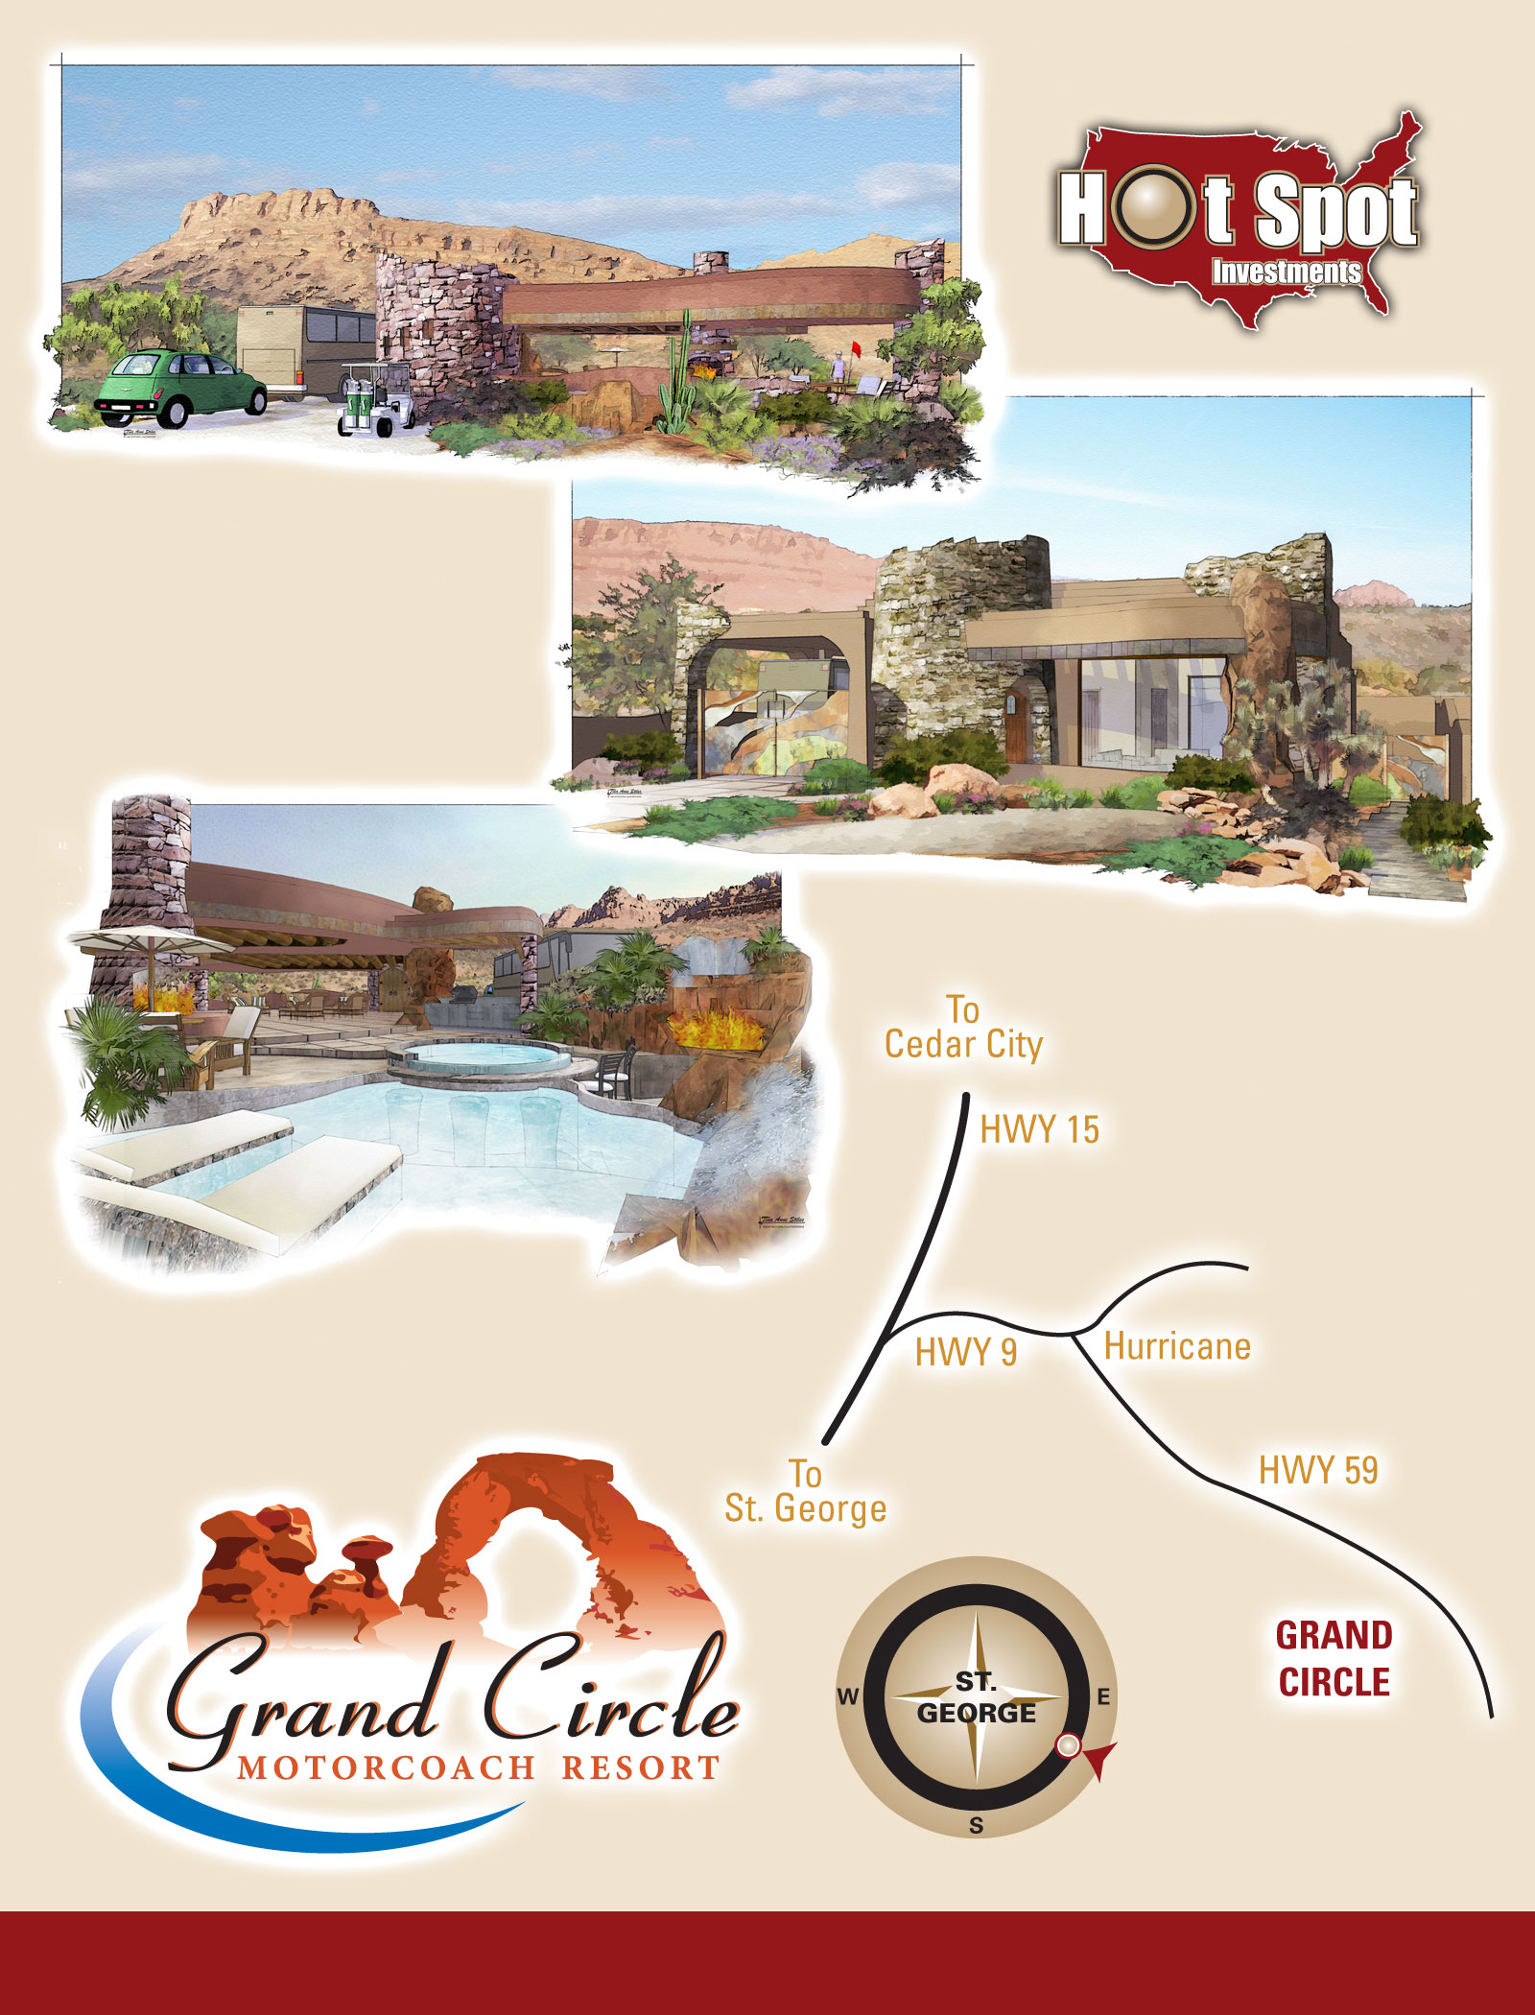**Grand Circle Motorcoach Resort**

**1-877-789-GROW**

|  |  |
| --- | --- |
| **Lot uses** | **Motorcoach and RV. Custom Casita & or Outdoor Casita options.** |
| **Lot sizes** | **3,000 to 10,000+ square foot** |
| **Access** | **Paved road.** |
| **Utilities** | **Full hookup.** |
| **Miscellaneous** | Luxury Motorcoach living re-invented! This luxury year round Resort is located just 20 minutes from St George Utah. It is surrounded by the largest concentration of State and Federal Parks in the United States. This region provides a never ending playground, with scenery, hiking, boating, world class Mountain Biking, fishing, gambling, snow skiing, ampitheatre entertainment, fine dining and any pleasure imaginable within your backyard.  Conservative lots are estimated to start at $149,000., larger lots with luxury upgrades are estimated to start at $249,000. There are countless custom upgrade and build options available, including revolutionary Casitas built like mini mansions and massive Outdoor Living Environments with kitchens, fireplaces, waterfalls, landscaping, master bathrooms, storage rooms, and much more. The 16,000+/- square feet clubhouse and exotic pools and waterfalls will be unsurpassed in stature.  Grand Circle Motorcoach Resort will be a true home base, and built for those seeking the finest lifestyle available.  Preconstruction pricing will be offered on any lots reserved. Reservations are being taken at this time. |
| **Dues** | **To be determined.** |
| **Seller** | **Utahlands.com/Partners** |
| **Down Payment** | **To be determined.** |

**Water Rights For Sale**

**1 acre ft = 2 Domestic aka Residential at .45 indoor only which equals .90, and 4 stock aka Animal units aka 4 horse/cattle/etc, equaling approximately .028 acre ft per unit. 1 ac ft = 325,900 gallons/year.**

**Sanpete County – Ask for current pricing per acre foot/share.**

Seller financing available with $500.+/- down, $100.+/- per month.

You may buy more or less than 1 acre foot, in .25 ac ft increments (except .50 minimum in Indianola Irrigation. Co).

All fees associated with the division of water rights or the irrigation companies shall be paid by the Buyer.

● Indianola Irrigation Company(must buy at least .5 ac ft): Water # for inquiry on transferability 51-375

$350 permanent change fee, $35 Certificate Fee and any other state fees shall be paid by the Buyer.

● Northern District, Indianola Area, Rennert Investment Co, Water number for inquiry on transferability: 51-234

● Southern District, Fairview Area: Water number for inquiry on transferability: 65-2378

**Utah County – Pending Sale on all Utah County water rights.**

$15,000. per acre foot, seller financing available with $500.+/- down, $350.+/- per month.

You may buy more or less than 1 acre foot in .25 ac ft increments.

● Cedar Valley Area: Water number for inquiry on transferability: 54-1019 (which is a portion of 51-3672, change application # a22732).

**Tooele County – May Be Coming Soon! Ask for details.**

***Contact Info***

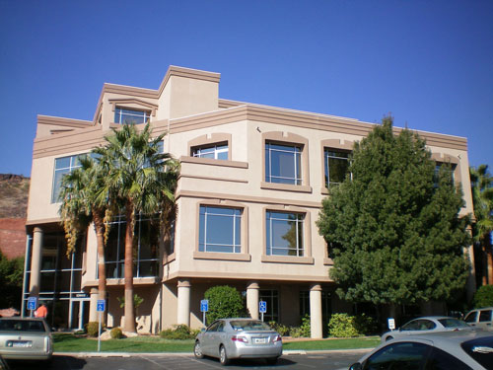

**Address for Red Z inc, Utahlands.com P.C., Hotspotinvestments.com PLLC ,**

**Elk Horn Agricultural LLC**

321 N Mall Dr, Ste L 101, St. George, UT 84790 Fax 435-921-0011

**Co-Owner/Broker, CEO:**

Jaime Smith cell: 801-599-8982,

Toll Free: 1-877-789-GROW (4769) Office: 435-703-9740

[jaime@hotspotinvestments.com](mailto:jaime@hotspotinvestments.com)

**Co-Owner;** Fred Smith cell: 435-669-4117

**SLC Client Education Specialists:**

Stan Parrish cell: 801-800-6776

stanparrish@gmail.com

**SLC Office:** 1817 East Ski View Drive, Sandy, Ut 84092. Off 801-545-0493 Fax 801-545-0468

**Accounting, Client and Office Management:** Sue Christensen, 435-703-9740

See more & Print out: product info, resell potential info, education info, pictures, ETC at:

[**www.HotSpotInvestments.com**](http://www.HotSpotInvestments.com) [**www.TheSandhillsResort.com**](http://www.TheSandhillsResort.com) [**www.OwnTheMt.com**](http://www.OwnTheMt.com)

Websites Under Construction: [www.grandcircleresort.com](http://www.grandcircleresort.com), [www.freevipreport.com](http://www.freevipreport.com)

***Owners***



***Our Mission***

After more than four decades helping thousands of clients… It is our family’s proud mission to provide life-changing education and one of a kind non-traditional retirement plan opportunities, so that our clients can build the financial security they need, to afford the retirement they deserve. Protecting and growing wealth today is more crucial than ever before. All real wealth is created over time so we have created an affordable and revolutionary solution, using better, safer and proven principles.

**Fred Smith 435-619-4347 Office 435-703-9740**

[redz3434x@gmail.com](mailto:redz3434x@gmail.com)

40 year veteran – “After working as a bank teller, I began investing in un-inflated land once I realized that the largest bank deposits routinely came from land sale profits. Having developed and sold thousands of un-inflated properties, I have never seen a safer or better way to leverage money and create more wealth.”

• Co-Owner, Developer, Utah Real Estate Agent.

• Survived every economic condition for over 40 years.

• Thousands of transactions.

**Jaime Smith 801-599-8982Toll Free: 1-877-789-GROW (4769) Office: 435-703-9740**

[jaime@hotspotinvestments.com](mailto:jaime@hotspotinvestments.com)

13 year veteran – “I started only with an opportunity to learn and to work. Seeing my father’s success encouraged me to invest as much as I could afford. It’s amazing for me to think I have built a retirement portfolio in 13 years far above what I ever thought possible. I love what I do and I am honored to help my clients succeed!”

• Co-Owner, CEO, Developer, Utah Real Estate Broker

• Revolutionized and grew the business substantially

• Thousands of transactions

• Record sales production



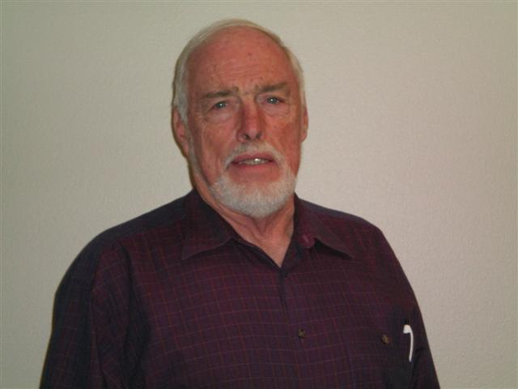

Laurel Malin

Accounting Manager

Brandon Smith

Client Education Specialist

David Gubler

Client Education Specialist

Mckell Sweet

Utah Realtor

Susan Christensen

Office Manager

Laurel Malen

Accounting